# CS 255 System Design Document Template

## UML Diagrams

### UML Use Case Diagram

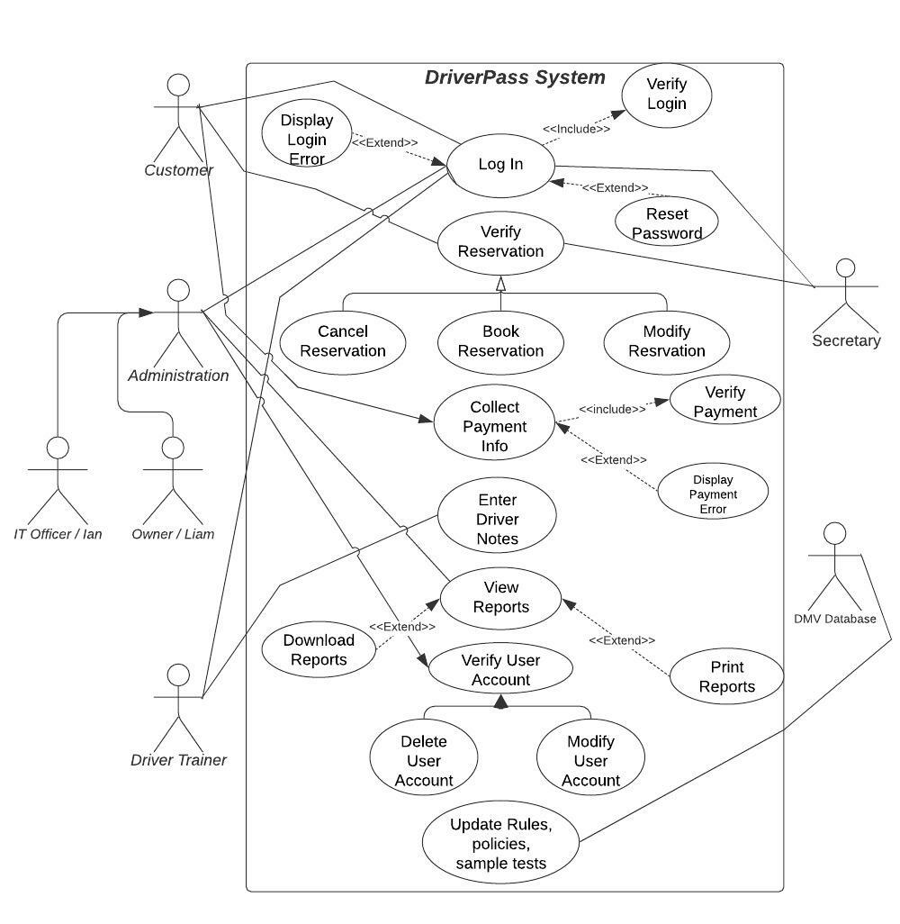

### UML Activity Diagrams

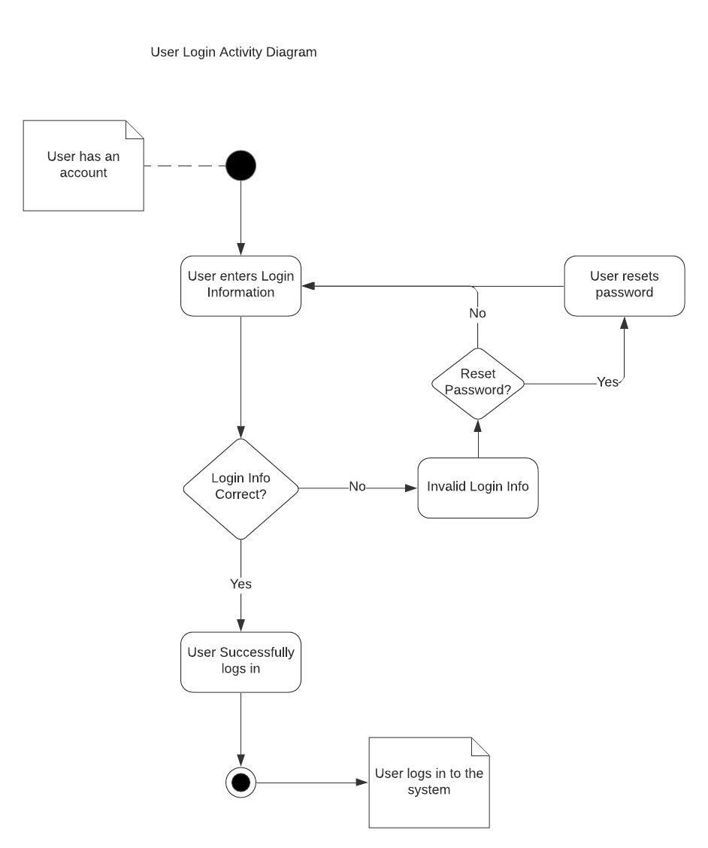

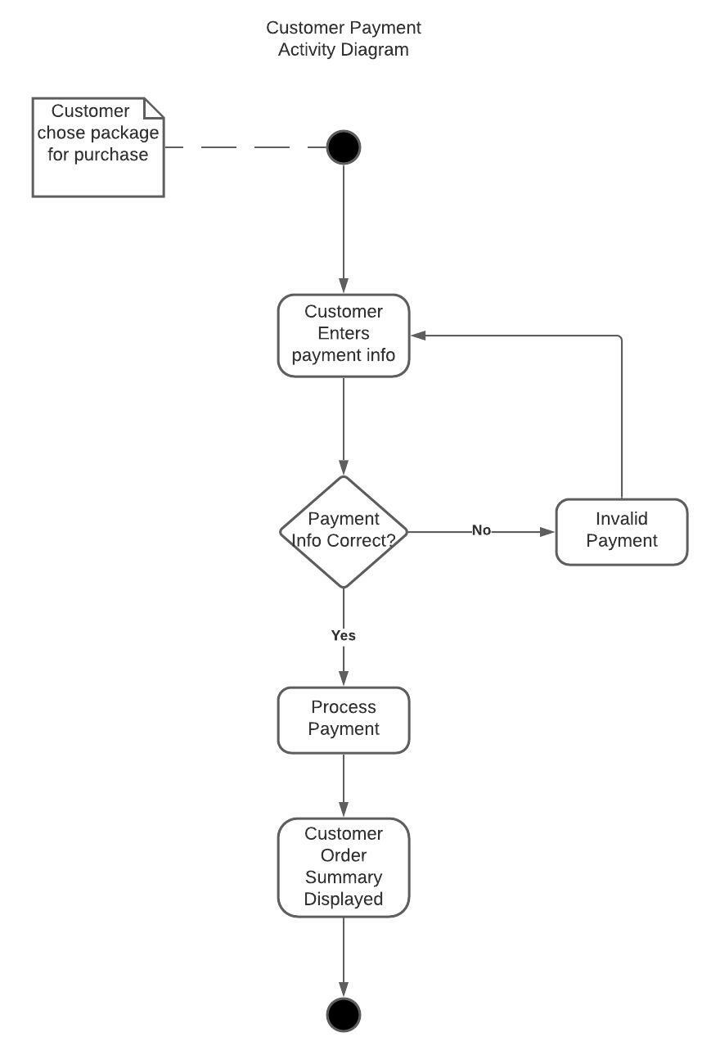

### UML Sequence Diagram

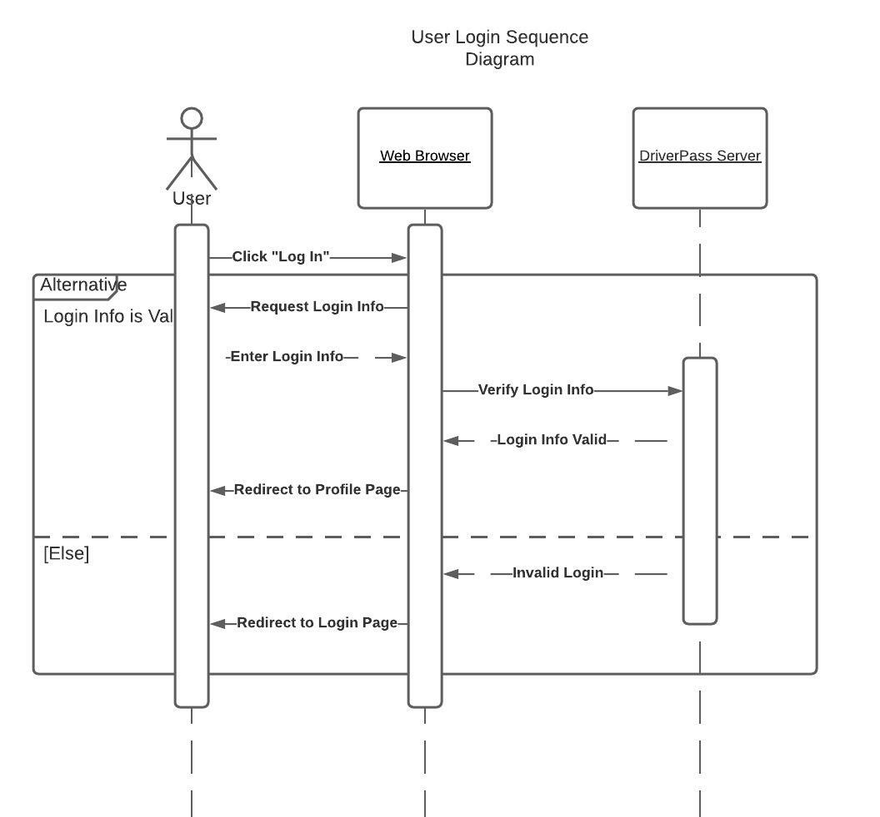

### UML Class Diagram

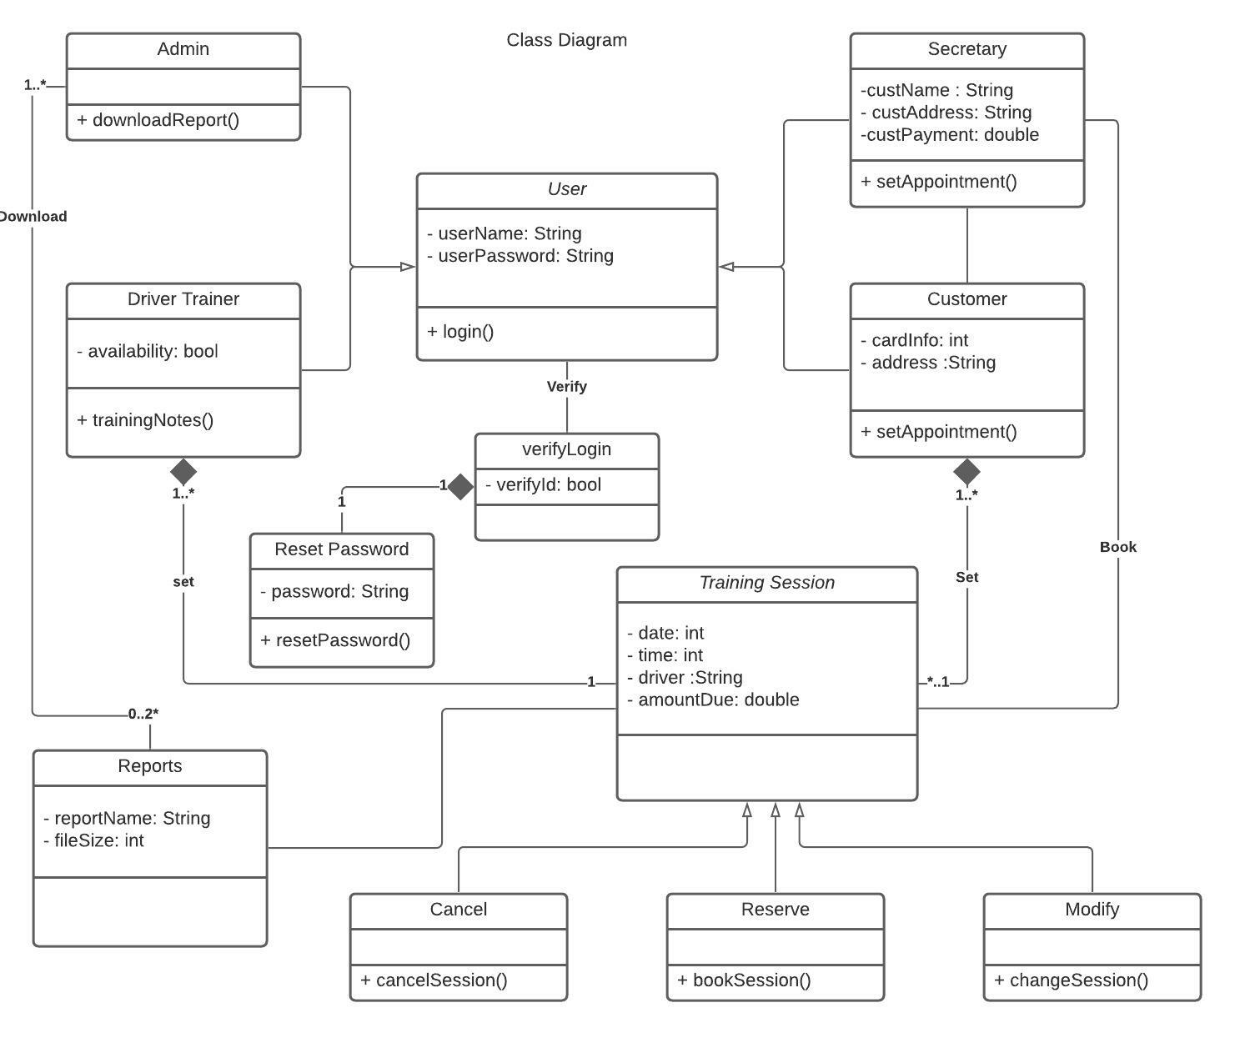

## Technical Requirements

The technical requirements of the Driverpass system are as follows:

1. The system can only be accessed via a web browser from a computer or mobile device.
2. Driverpass will be run via a cloud database. Driverpass will not require physical servers.
3. The Driverpass system will run on Windows OS, Mac OS, and Linux OS. This will keep open the ability to access Driverpass via mobile devices (Android is an open-source Linux OS, and IOS is compatible with Mac OS capable systems)
4. The payment portion of the system must have access to a POS (Point of Sale) payment processing software in order for customers to purchase driving packages.
5. The system will need to have access to each state’s DMV database in order to update policies, rules and practice tests.